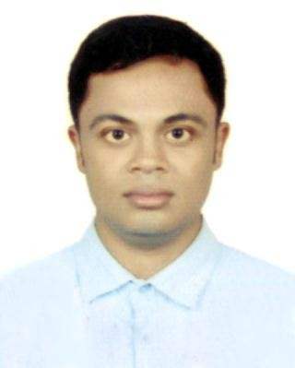

## Current Address

RESUME OF MD. LIMON

10 C.A.R.C Tower, 74, Elephant Road Newmarket, Dhaka

Phone: 01627809995

E-mail: [mdlimonahmed821@gmail.com](mailto:mdlimonahmed821@gmail.com)

# CAREER OBJECTIVE

PHOTO

Building up a career in challenging and dignified position in an organization where creativity, sincerity skill and performances are the criteria for one’s appraisal. To work meaningfully through consistency, discipline and hard work in creative and competitive environment based on strong commitment and of course to serve the nation.

# EDUCATIONAL BACKGROUND:

## Diploma in Engineering

Institute : Barishal Polytechnic Institute

Subject : Electronics Technology

Board : BTEB

Passing Year 2020

Result : CGAP-3.11 (out of 4.00)

## Secondary School Certificate (SSC)

Institute : Adakhola Secondary School, Jhalokati Group : General Electrical Works

Board : BTEB

Result : GAP-4.54 (out of 5.00)

Passing Year 2016

# INDUSTRIAL TRAINING

Institute : Walton Service Center Topic Covered : Television

Duration : 3 Months

Address : Patuakhali

# INDUSTRIAL SUMMERY

Institute : National Youth Training Academy (NYTA) Topic Covered : Certificate in Computer Application Duration : 12/11/2020 to 11/02/2021 (3 Months) Address : Chattagram, Bangladesh

Institute : Samsung Service Center Topic Covered : Mobile Servicing

Duration : 12/03/2021 to 11/09/2021 (6Months) Address : Barishal, Bangladesh

Topic Covered : Mobile Servicing

Duration : 12/03/2021 to 11/09/2021 (6Months) Address : Barishal, Bangladesh

Institute : Siam IT

Topic Covered : IT Support Engineer

Duration : 01/03/2022 to 01/03/2023 (1Year) Address : Banani, Dhaka, Bangladesh

# LANGUAGE EFFICIENCY

* Have good communication skill in English
* Well capable of communicating people in Bangle

# COMPUTER SILL

Microsoft Office: Ms. Word, Ms. Excel, Fundamental of Browsing, Windows & Internet Browsing etc.

# SELF ANALYSIS

* Strong Motivation & Commitment
* Ability to work independently as well as in team
* Endurance to work for long hours & under pressure
* Pleasant personally and good inter personal skills

# PERSONAL INFORMATION

* Father’s Name : Md. Salim Sikder
* Mother’s Name : Mst. Masuma Begum
* Date of Birth : 4th March 2000
* Permanent Address : Vill: Adakhola, P.O- Uttompur

P.S: Rajapur, Dist. Jhalokati

* Nationality : Bangladeshi By Birth
* National ID No : 3311368298
* Sex : Male
* Marital Status : Unmarried
* Religion : Islam

# DECLARATION:

To the best my knowledge the above-mentioned information is true and I am aware about the fact that may misrepresentation of information might be treated as disqualification for me.

Date: Signature ................................

Md. Limon